VIJAYA INSTITUTE OF TECHNOLOGY FOR WOMEN
DEPARTMENT OF BUSINESS ADMINISTRATION
BATCH(2017-19) PLACEMENTS
SNO | COMPANY NAME | PHOTO | ROLL NO | NAME OF THE STUDENT
1 | RAKI AVENUES PVT LTD |  | 177Q1E0025 | V.SUKANYA
 |  |  | 177Q1E0005 | CH.GAYATHRI
 |  |  | 177Q1E0036 | K.VIJAYA VENKATA  SRILAKSHMI SRAVYA
 |  | 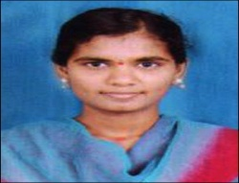 | 17NP1E0016 | G.MOUNIKA
 |  |  | 177Q1E0031 | P.ANUSHA
2 | HDFC |  | 17NP1E0002 | R.AMARAVATHI
3 | BR CONCEPTS | 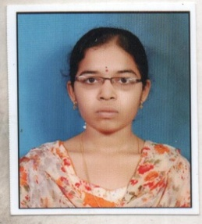 | 17NP1E0023 | T.ROJA
 |  | 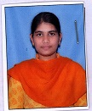 | 177Q1E0023 | G.SRAVIKA
 |  |  | 177Q1E0007 | HASINA SYED
4 | KANAKA DURGA FINANCE | 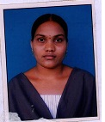 | 177Q1E0009 | Y.LAKSHMI TIRUPATHAMMA
 |  | 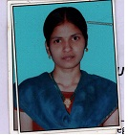 | 177Q1E0014 | M.PADMA
 |  | 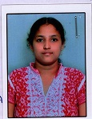 | 177Q1E0015 | R.POORNA KOMALI
 |  |  | 17NP1E0015 | G.MOUNICA
 |  |  | 177Q1E0016 | RASHEEDA SHAIK
 |  |  | 177Q1E0023 | G.SRAVIKA
 |  |  | 17NP1E0006 | L.DURGA BHAVANI
5 | DAMAGATLA TECHNO SOLUTIONS |  | 177Q1E0001 | A.AMANI
 |  |  | 177Q1E0016 | RASHEEDA SHAIK
 |  |  | 177Q1E0023 | G.SRAVIKA
6 | ALIENS GROUP | 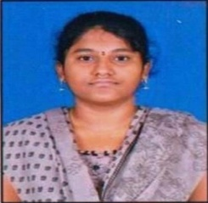 | 17NP1E0010 | T.JYOTHSNA
 |  | 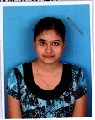 | 177Q1E0008 | CH.KALPAVALLI
 |  | 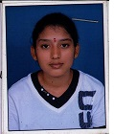 | 177Q1E0028 | T.VEENA
 |  | 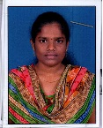 | 177Q1E0004 | B.BHUVANESWARI
 |  |  | 177Q1E0036 | K.VIJAYA VENKATA  SRILAKSHMI SRAVYA
 |  | 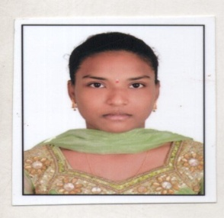 | 17NP1E0008 | M.GIRIJA
 |  | S | 177Q1E0023 | G.SRAVIKA
 |  |  | 177Q1E0015 | R.POORNA KOMALI
7 | KARVY FINANCE |  | 177Q1E0029 | N.VIJAYA DURGA
 |  |  | 177Q1E0008 | CH.KALPAVALLI
 |  | 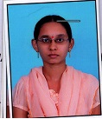 | 177Q1E0010 | K.MADHAVI
 |  |  | 177Q1E0011 | G.MOUNIKA
 |  |  | 17NP1E0015 | G.MOUNICA
 |  | 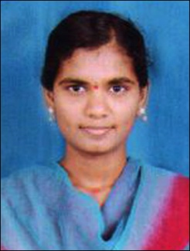 | 17NP1E0016 | G.MOUNIKA
8 | ETERNAL ORG |  | 177Q1E0004 | B.BHUVANESWARI
9 | MUTHOOT FINANCE |  | 177Q1E0008 | CH.KALPAVALLI
 |  |  | 177Q1E0007 | HASINA SYED
10 | ICICI | 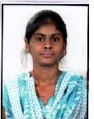 | 177Q1E0033 | J.MOUNI SRI
 |  |  | 177Q1E0004 | B.BHUVANESWARI
 |  | 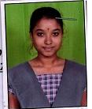 | 177Q1E0025 | V.SUKANYA
 |  |  | 177Q1E0009 | Y.LAKSHMI TIRUPATHAMMA
 |  | 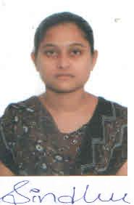 | 177Q1E0020 | B.SINDHU PRASANNA
 |  |  | 17NP1E0011 | P.KAVYANIKITHA
 |  | 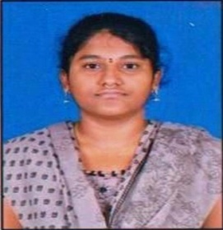 | 17NP1E0010 | T.JYOTHSNA
11 | ACRUX SOLUTIONS |  | 177Q1E0011 | G.MOUNIKA
12 | PARIKARAM IT SOLUTIONS | 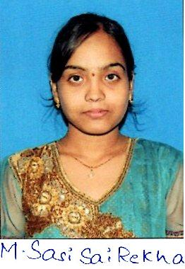 | 177Q1E0018 | M.SASI SAI REKHA
 |  |  | 177Q1E0020 | B.SINDHU PRASANNA
 |  | 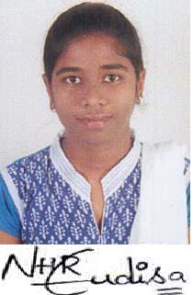 | 177Q1E0013 | G.NIHARIKA
 |  |  | 177Q1E0031 | P.ANUSHA
13 | ILM |  | 17NP1E0006 | L.DURGA BHAVANI
14 | VISION AND AADHYA FINANCE | 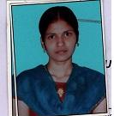 | 177Q1E0014 | M.PADMA
 |  | 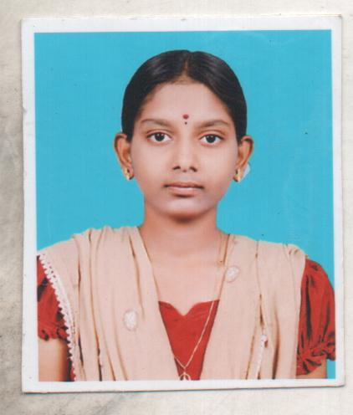 | 17NP1E0024 | N.SAISATYAPRIYA

